Name: Gunnar Forcier Oral/Interpersonal Communication

Chapter 2 Activity: Perception and Self-Concept (10 Points)

**1. Who are you?** After reading Section 2.3, complete the table below based on how you perceive yourself and how you *think* other perceive you. Type your responses in the gray boxes. To receive full credit, provide information in each of the table’s cells (boxes). Once you have completed the table, respond to the questions at the bottom of the page.

|  |  |  |
| --- | --- | --- |
| **Traits to Consider** | **How do you see yourself?**  **(“I” statements)** | **How do you think others see you? (What would they say about you?)** |
| **Abilities/Talents**  Things your are capable (or not capable) of doing | I love cooking and hope to be alright at it. I am pretty good at video games. I’m terrible at advocating for myself and my needs. | Other people have said that I’m an alright cook and can make good food. My partner says I’m pretty darn good at video games. Other’s say I’m improving at self-advocating. |
| **Roles you play**  Things you do because of your social or actual functions (mother, student, waiter, brother) | I’m a son, student, pet owner, and lunch lady. | I think most people see me as young, aloof, and kind. |
| **Personality**  Ways you act or emotions you have | I’m a kind person, but I’m also quite closed off at times. It takes a lot for me to get angry, so it rarely comes out. Maybe mopey sometimes. | I think most would say I’m kind and aloof, but also can be very introverted depending on the day. |
| **Values/Beliefs**  What you feel you should or should not feel, do, believe | I enjoy making connections with people and it’s relatively easy making new friends, but I find it hard to maintain those relationships. I believe in being kind to someone no matter the circumstance. | Making connections and being kind and accepting. I think that comes across to others. |
| **Goals**  What you are working toward | I’m working toward a degree and a decently well-paying career. I have dreams of filmmaking one day, but that’s far in the future once I have money for equipment and classes. | Others would see that I’m working towards a degree, but that’s all they would see I think. |
| **Appearances**  Physical traits, clothing style, physical condition | I look okay, I guess. I’m not in the worst shape of my life, but not in the best either. Winter is never kind to my physical condition. | My partner says I’m very handsome, but my style could use work. |
| **Level of Intellect**  How you assess yourself for intelligence and/or “common sense” | I think I’m reasonably smart. I seem to be more aware of things than the average person, but I’m forgetful and unintelligent in many areas. | I don’t think people would say I’m stupid. Forgetful yes, but maybe slightly above average. |
| **Social Traits**  Interaction with others, behaviors exhibited | I approach others kindly and respectfully no matter the ethnicity or gender identity. I try to reciprocate interests and empathize with whoever I’m interacting with. | Others would think I’m either weird, or kind and accepting depending on the situation. I can be a little weird sometimes, so people can be a bit offput. |

**2. Based on your responses from above, *write a brief paragraph that describes and analyzes how you see (perceive) yourself based on the questions below.***

My most important values are, treating everybody with respect and kindness, and making connections with people. I don’t believe my two perceptions differ much from how they’re perceived, maybe I chose bad examples, but the things that are most important to me are things that I think most people perceive about me.

My ideal self is the person who believes wholeheartedly in treating everybody with respect and kindness and making connections with people. My actual self also believes in these values, but there are certainly exceptions. There are people that I just do not care for, and don’t bother trying to connect with for not the best reasons. My ought self is pretty much identical to my ideal self, I think. My obligation to treat everyone with kindness is the same as my goal for my ideal self.

**3. In the area below, insert an image of a personal item that is significant to you. (If you prefer, you may upload a separate image along with this document in Canvas.) In a few sentences,** explain how the item reflects your self-concept and your perception the world. (Consider the traits you included in the table from page 1.) If you need help adding images to your document, follow this link: [Insert Pictures (Microsoft Word)](https://support.microsoft.com/en-us/office/insert-pictures-3c51edf4-22e1-460a-b372-9329a8724344#ID0EABAAA=Windows_newer_versions).

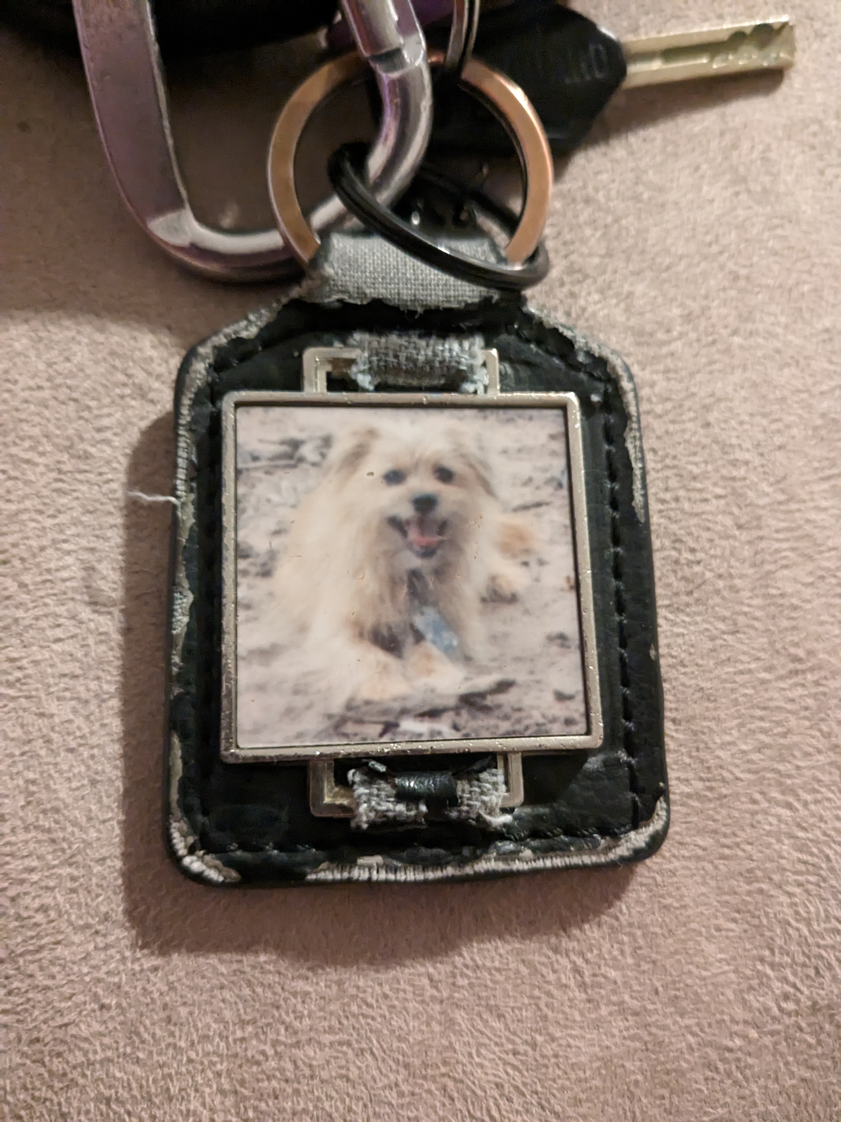

This is an item that’s very special to me. It’s a keychain my mom got me when I was in high school of my dog Murphy. He’s now passed, so it’s only been made more important to me over the years. I see a lot of my perception in this item. I see my love of animals, love of broken things and people, and a simpler time. I often perceive myself as a broken, ugly person. But, this item, while partially broken and worn, will always have a piece that’s genuinely happy and grateful. So it’s kind of fitting to be a keychain and something that I always have with me. Some days catching a glimpse of it can be all the inspiration to get through the day.